Final Study Guide

Unit 1 Study Guide

Economic Reasoning, Scarcity, Choice and Cost

- What is Scarcity and why is it such an important aspect of economics?
- What is the difference between something that is Scarce vs. something that is Rare?
- What are examples of Alternatives?
- What is “Human Capital”?
- What is the difference between Normative and Positive economics?
- What is the difference between a Positive and Negative Externality?
- What are the 4 Economic Goals?
- What are the 5 Socio-Economic Goals?
- How do you define Opportunity Cost? What is PPF?
- What is Cost-Benefit Analysis/Rule?
- What is the Law of Diminishing Marginal Returns?
- What is the Law of Diminishing Marginal Utility?
- How do you define Utility?
- What are Economic Resources?
- What is the difference between Positive, Negative and Perverse Incentives?
- Zero vs. Positive Sum Games
- Business cycle
- GDP
- Inflation
- Recession v Depression
- Unemployment types, acceptable rates, underemployment, discouraged workers, and how to calculate unemployment

ECONOMIC REASONING AND ITS RELEVANCE FOR YOU
Jim Charkins
Economic Proposition | In English | Lesson for Life
Scarcity | You can't have everything you want. | Acceptance of scarcity will help you make more reasoned choices.
Alternatives | Different options from which you can choose. | There are many different ways to allocate resources and to solve problems.
Choice | Because you can't have everything you want, you have to make choices from a list of alternatives. | When policy-makers decide on a particular resource allocation, recognize that a choice had to be made due to scarcity. You may not like the alternative chosen, you may question the choice, but the villain is scarcity.
Trade-offs | Choices involve giving up something to get something. All choices have consequences, both positive and negative. | You are responsible for the consequences of your choices. Since you make choices, you can't be a victim.
Opportunity Cost | A resource can only be allocated to one thing at a time. The opportunity cost of deciding to do one thing is the next best alternative use of the resource. | All choices have opportunity costs. A good idea is only a good idea if its value is greater than the value of its opportunity cost. Voters must always identify the opportunity cost of a particular policy.
Benefit/Cost Analysis | Is it worth it? Are the positive aspects of the action greater than the negative aspects? Is it a "good deal?" | Analyzing positive and negative aspects of potential decisions forces you to think more carefully about your choices.
Comparative Benefit/Cost Analysis | Even if it is a good deal, is this the best deal? Is this the best use of limited resources? | Putting the decision in the context of all alternative uses of your resources helps you see your world in its completeness.
Marginal Benefit/Cost Analysis | OK, you've used all your resources. Now you get some more. Where should they go so that you get the greatest additional benefit for every additional resource you use. | The concept of the margin allows you to answer questions such as: "How much school should I have?" "Should I buy the bigger stereo?" "How much should I study and how much TV should I watch? How much is too much, how much is not enough? Is this the straw that will break the camel's back?"
Sunk Costs | Regardless of how high the costs were in the past, the important question is whether future additional benefits are greater than future additional costs. Past costs are not relevant in the decision. | Concentrating on the future instead of the past allows you to work on what you can control as opposed to what you cannot control.

Unit 2
Comparative Economics
Study Guide
(Economic Theorists, Command Economies, Economies in Transition, Market Economics & Market Structures

- Adam Smith wrote what book?
- What does the Invisible Hand do?
- Competition leads to the achievement of what Economic Goals?
- Absolute vs. Comparative Advantage
- What are the characteristics of a Market, Traditional and Command/Centrally Directed Economy?
- What goals are achieved and not achieved in each economic system?
- Most countries in the world today run under which economic system? Why?
- What are examples of a Market, Traditional and Command Economy?
- Economic Thinkers
- Economic Systems
- Market Structures
- Eminent Domain
- Gini Coefficient & Lorenz Curve
- Comparative and Absolute Advantage.
- Tragedy of the Commons
- Voluntary Trade
- Production Possibilities Frontier
- Public vs. Private Goods
- Creative Destruction

Supply and Demand
Unit 3 Study Guide

- What factors determine Demand? Elasticity of Demand?
- What factors determine Supply? Elasticity of Supply?
- What does the Equilibrium Price/Market Clearing Price determine?
- What does the Quantity Demanded mean?
- What does the Quantity Supplied mean?
- What are shortages? Surpluses? Price floors? Price ceilings?
- Normal and Inferior Goods
- Veblen and Giffen Goods
- Demand Schedules
- Price vs. Costs

Label the bottom row of each side of the table to tell whether the relationship between price and quantity (bunches of roses) describes the behavior of a buyer or a seller. (You may make a supply and demand graph if you feel it would help you.)

Price Bunches of Flowers Price Bunches of Flowers
$5.00 | 15 |  | $7.50 | 50
$7.00 | 20 |  | $9.00 | 45
$9.00 | 30 |  | $12.00 | 38
$12.00 | 38 |  | $15.00 | 27
$15.00 | 75 |  | $21.00 | 5

What is the Market Clearing Price and how do you know?

Label the following items on the graph below:

- The Supply Curve

- The Demand Curve

- The Equilibrium Price/Market Clearing Price

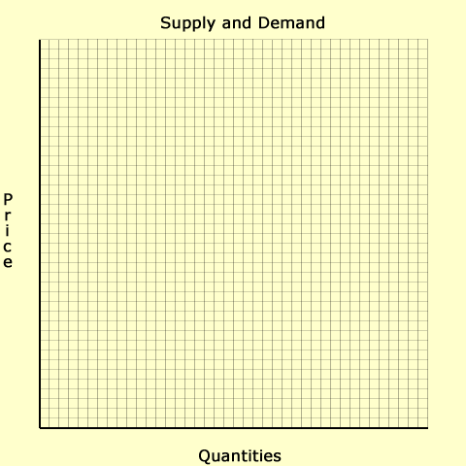

Practice Supply and Demand:

A tax rebate increases incomes. The government decides to subsidize oil companies.
New Cars Oil

P _____ Q_____ P _____ Q____

Storms ruin citrus crops in Florida. The price of orange juice rises.
Oranges Apple Juice

P _____ Q_____ P _____ Q_____

Unit 4 Study Guide
Aggregate Demand & Supply
The Government & the Economy
Financial Literacy

- Aggregate Supply and Demand ie. What happens to unemployment, reasons for shifts, price levels, Real GDP, various scenarios
- What is the difference between a Debt and a Deficit?
- Who is the “Fed” and what do they do?
- What is the value of Money and how can it be defined?
- What does the Money Supply include?
- What is Fiscal Policy?
- Who is in charge of Fiscal Policy?
- What has a greater impact on Fiscal Policy government spending or tax changes?
- What is Monetary Policy?
- Who is in charge of Monetary Policy?
- Who is the Chairperson of the Federal Reserve Bank?
- What are the four characteristics of a “Fair” tax?
- Describe the difference between a Progressive, Regressive and Proportional Tax.
- What are the “7 Deadly Taxes” and what type of tax are they?
- Where do the different levels of government spend most of their taxes?
- What goal (economic/socioeconomic) or goals are achieved when we use tax money to help others who cannot help themselves?
- Guns vs. Butter debates
- Why do people dislike paying taxes?
- Net income vs. Gross Income, Discretionary income/spending
- Priciple, interest, equity, types of investments, liquidity
- Subsidized vs. Unsubsidized loans, compound interest, credit
- Premiums vs. Dedcutibles, types of insurance, wills,

- Using the following tax bracket calculated the taxes for the following salaries:
- $150,000
- $26,750
- $85,127

Tax Bracket-
10% from 0-7,550
15% from 7,551-30,650
25% from 30,651-74,200
28% from 74,201-154,800
33% from 154,801-336,550

