School spending by affluent is widening wealth gap
Associated Press
JOSH BOAK AP Economics Writer 5 days ago
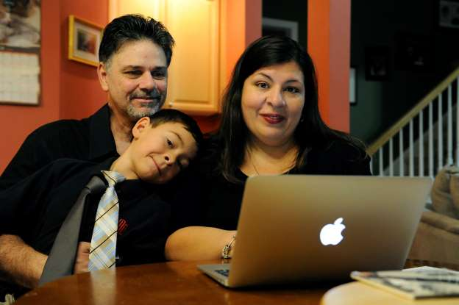© AP Photo/David Tulis Marisela Martinez-Cola, right, a lawyer and a parent living in an Atlanta suburb with her husband Greg, left, and their 7-year-old son, David, pose for photos as they prepare for a typical school and work day Tuesday, Sept. 30, 2014, in Lawrenceville, Ga. The couple send their son to private school and have hired a tutor to improve David's reading _ expenses made possible by Greg’s salary as a regional buyer for Costco Wholesale.
WASHINGTON — Education is supposed to help bridge the gap between the wealthiest people and everyone else. Ask the experts, and they'll count the ways:
Preschool can lift children from poverty. Top high schools prepare students for college. A college degree boosts pay over a lifetime. And the U.S. economy would grow faster if more people stayed in school longer.
Plenty of data back them up. But the data also show something else:
Wealthier parents have been stepping up education spending so aggressively that they're widening the nation's wealth gap. When the Great Recession struck in late 2007 and squeezed most family budgets, the top 10 percent of earners — with incomes averaging $253,146 — went in a different direction: They doubled down on their kids' futures.
Their average education spending per child jumped 35 percent to $5,210 a year during the recession compared with the two preceding years — and they sustained that faster pace through the recovery. For the remaining 90 percent of households, such spending averaged around a flat $1,000, according to research by Emory University sociologist Sabino Kornrich.
"People at the top just have so much income now that they're easily able to spend more on their kids," Kornrich said.
The sums being spent by wealthier parents amount to a kind of calculated investment in their children. Research has linked the additional dollars to increased SAT scores, a greater likelihood of graduating from college and the prospect of future job security and high salaries.
The trend emerged gradually over the past three decades but accelerated during the worst economic slump since the 1930s. Now, enrollments at pricier private schools are climbing. Parents are bidding up home prices in top public school districts. Pay is surging for SAT tutors, who now average twice the median U.S. hourly wage of $24.45. The patterns suggest that the wealth gap could widen in coming years, analysts say.
"If you're at the bottom and the top keeps pulling away, you're just further behind," said Melissa Kearney, a senior economics fellow at the Brookings Institution.
Between 2007 and 2011, enrollment at private elementary and secondary schools whose annual tuition averaged $28,340 — more than half the median U.S. household income — jumped 36 percent, according to federal data. The intensified reach for the costliest schools occurred even as enrollment in private schools overall fell.
"What we know about parents who send their kids to private school is that by and large they place a very high priority on education," said John Chubb, president of the National Association of Independent Schools. "As prices go up, they may be frustrated and angry, but they find a way to make it work."
Most families can't compete. Incomes have barely budged for most Americans since 1980 after accounting for inflation. For the top 10 percent, IRS data show pay has jumped 80 percent after inflation. For the top 1 percent, it's soared 177 percent.
The education divide has grown despite the multi-decade presence of Head Start, the federal program for nutrition and early childhood education. Most states rely primarily on a private pre-school system that can reinforce the wealth gap, said Sean Reardon, a Stanford University professor who has studied education and income inequality.
Head Start-backed programs "alone are insufficient to close these gaps," Reardon said.
Among those spending more is Marisela Martinez-Cola's family. A suburban Atlanta mother, Martinez-Cola sends her 7-year-old son to private school and has hired a tutor to improve his reading — expenses made possible by her husband's salary as a regional buyer for Costco Wholesale.
"Fortunately, for us, it's not a choice between him and groceries," she said.
The disparities in education spending emerge practically at birth.
A family earning $39,360 spent an average of $2,070 per child for preschool and day care last year, the government reported. Families earning $186,460 spent $5,370 — 159 percent more than lower-income families.
Wealthier parents can also afford high-quality day care, which better prepares children for kindergarten, said Steven Barnett, director at the National Institute for Early Education Research.
Many also pay a premium to live in top public school districts. Homes in top-rated school zones command a 32 percent premium over the national average, real estate data firm Trulia has found.
The real estate brokerage Redfin has found that homes in top districts sell faster than others and are more likely to incite bidding wars. In Alexandria, Virginia, a 3,000-square-foot home near a highly ranked school sold last year for $920,000 — $130,000 more than a similar home less than a mile away with an average-rated school.
One family with four children bought a small three-bedroom ranch home in late 2012 to land a spot in the prestigious New Trier School District in Chicago's North Shore suburbs, said David Yocum, a Redfin real estate agent.
The house drew roughly 25 offers and sold for $341,500. The successful buyers then added a second floor for more space.
"Every couple I work with in the North Shore is looking for homes that will get their kids into the right schools," Yocum said.
On top of that, there are the tutors. An average SAT tutor advertised through WyzAnt charges $51.20 an hour. Prices since 2012 have risen twice as fast as average wages tracked by the Bureau of Labor Statistics.
The disparity in spending patterns creates a hurdle for reducing income inequality through additional education — the preferred solution of many economists.
An August report by Standard & Poor's said higher educational achievement would fuel faster economic growth and help shrink income disparities. Thomas Piketty, the French economist whose exploration of tax data helped expose the wealth gap, has argued that education "is the most powerful equalizing force in the long run."
Affluent parents tend to get what they pay for: Their children score 125 points higher on SATs than those from the poorest homes, up from a gap of 90 points during the 1980s, according to research by Reardon, the Stanford professor.
Separate research shows their children are more likely to attend and complete college. Afterward, they have better access to higher-paying careers, Reardon said.
"The worry is that it becomes a feedback loop, where the children of the rich do the best in school, and those who do best in school become rich," Reardon said.
Some middle-income parents have come to feel that personal sacrifices are an acceptable price for giving their child a potential edge.
"You pay now vs. paying later," said Tysha Wheeler-Timmons of Rahway, New Jersey.
A contract coordinator for a pharmaceutical company married to a truck driver, Wheeler-Timmons earns modest pay. But she took a part-time security job to pay for $3,000 in tutoring for her daughter, Shayla, a high school senior aiming for an Ivy League bioengineering degree.
She worries about having to pay for similar opportunities for her two sons. Yet she feels she has no choice.
"I've been able to get a decent job, even though I don't have a college education," she said. "We're the last generation to do that."
