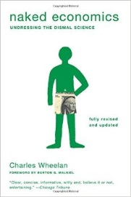

Chapter 3
Government and the Economy:
Government is your friend
(and a round of applause for all those lawyers)

1. Why is dealing with externalities a crucial role for government in a market? Provide an example.

2. How do positive externalities differ? Provide an example.

3. How does a good government make a market economy possible?

4. How does the government provide a wide array of “public goods” that make us better off, but would otherwise be provided by the private sector?

5. Explain how the following statement is both true and not true: “Taxpayers know better what to do with their money than the government does.”

Chapter 4
Government and the Economy II:
The army was lucky to get that screwdriver for $500

1. What are some things government should not be doing? List at least two examples and explain why.

2. How do government regulations have a cost? How should regulations be structured by the
government?

3. What correlation is there between standards in international countries with little regulations versus international countries with a lot of regulations?

4. Describe the differences in the way the private sector and the government sector allocate
resources?

Chapter 8
The Power of Organized Interests:
What economics can tell us about politics
1. Even if economists reach a consensus on public policy, why do they often run into political
opposition?

2. What are government subsidies? What are the effects of subsidies from an economic perspective?

3. How do politicians stifle the benefits of “creative destruction”?

4. How is trade good for the consumer? Provide an example to support your answer.

Chapter 10
The Federal Reserve:
Why that dollar in your pocket is more that just paper

1. What is the main job of the FED?

2. Explain the functions of money.

3. What are the primary tools the FOMC uses to influence the economy? Explain how they work.

4. What is the difference between money and wealth?

5. What are mediums of exchange?

